Query 1
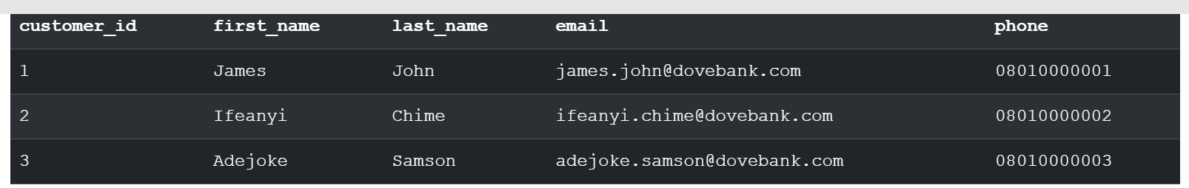

Query 2
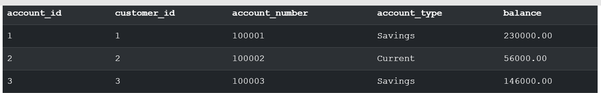

Query 3
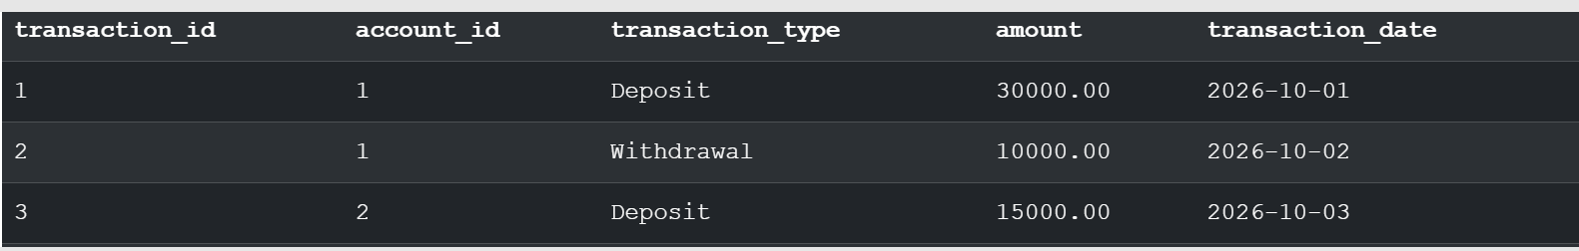


Query 4
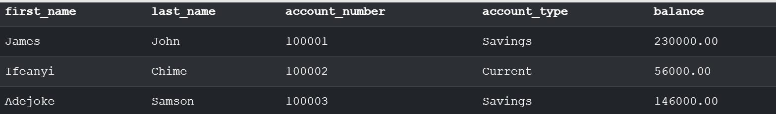

Query 5
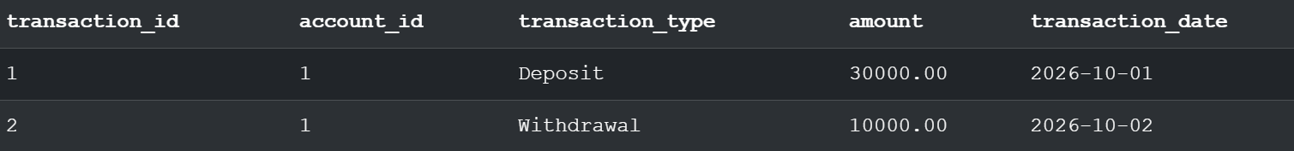

Query6
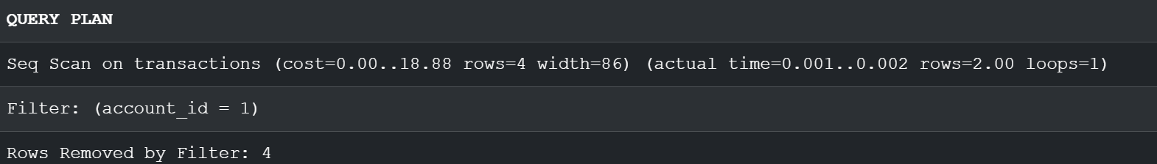


Query 7




